- Watch the Terraform-06 video.
Completed
- Execute the script shown in the video.
Terraform Modules:
Modules is a collection of configuration files in a directory.
Created directories
aws_instance
resource "aws_instance" "webserver"
ami = var.ami
instance_type = "t3.micro"
}
Variables:
Variables = “ami” {
}
main
module "dev-webserver" {
source = "../aws_instance"
ami = "ami-02f3f602d23f1659d"
}
- Provision EC2, S3, and VPC using Terraform modules.
Terraforminfra/
├── aws_instance/
│ ├── main.tf
│ └── variables.tf
├── aws_s3/
│ ├── main.tf
│ └── variables.tf
├── vpc/
│ ├── main.tf
│ └── variables.tf
└── module/
└── main.tf <-- this is the root file where you call the 3 modules
1.EC2 Module (aws_instance/)
main.tf
resource "aws_instance" "webserver" {
ami = var.ami
instance_type = "t2.micro"
}
variables.tf
variable "ami" {
description = "AMI ID to use for the EC2 instance"
type = string
}
2.S3 Module (aws_s3/)
main.tf
resource "aws_s3_bucket" "s3_bucket" {
bucket = var.bucket
}
variables.tf
variable "bucket" {
description = "Unique S3 bucket name"
type = string
}
3.VPC Module (vpc/)
main.tf
resource "aws_vpc" "this" {
cidr_block = var.vpc_cidr
tags = {
Name = "myvpc"
}
}
resource "aws_subnet" "this" {
vpc_id = aws_vpc.this.id
cidr_block = "10.0.1.0/24"
availability_zone = "us-east-1a"
}
variables.tf
variable "vpc_cidr" {
description = "CIDR block for the VPC"
type = string
default = "10.0.0.0/16"
}
4. Root Module (Calling All Modules)
Inside module/main.tf you are calling your child modules:
module "module-webserver" {
source = "../aws_instance"
ami = "ami-0d85d4f07a62e2969"
}
module "vpc" {
source = "../vpc"
vpc_cidr = "10.0.0.0/16"
}
module "s3" {
source = "../aws_s3"
bucket = "s3bucket69875"
}
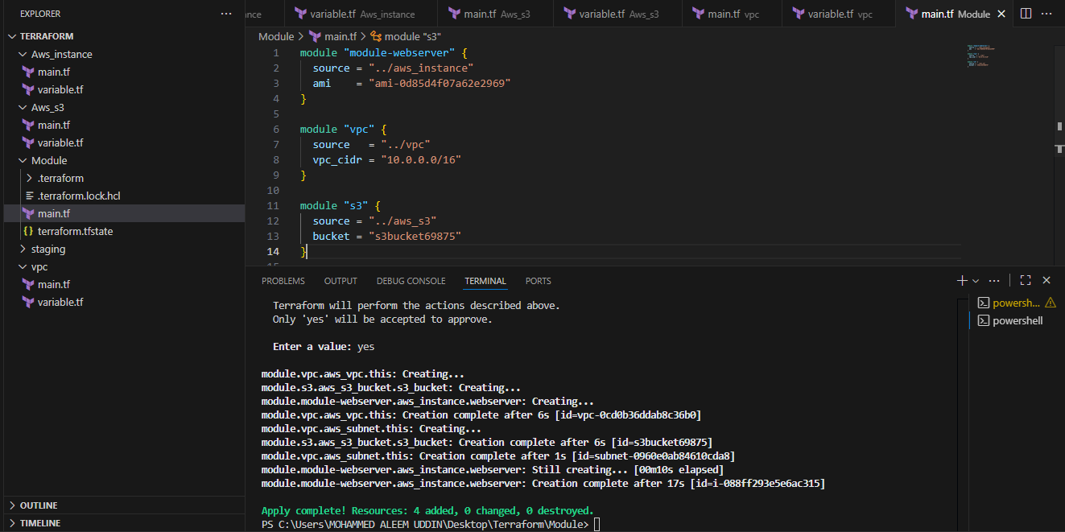
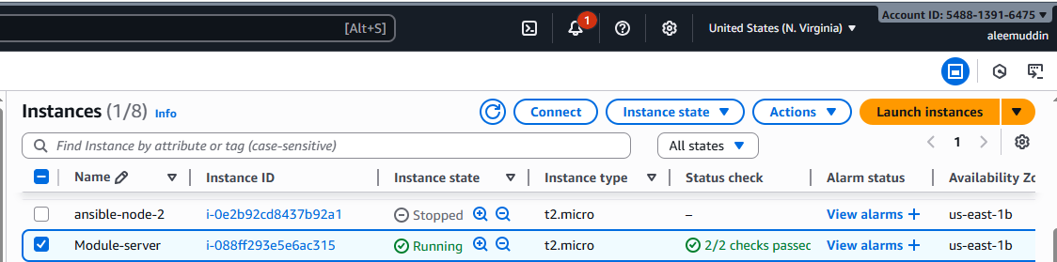
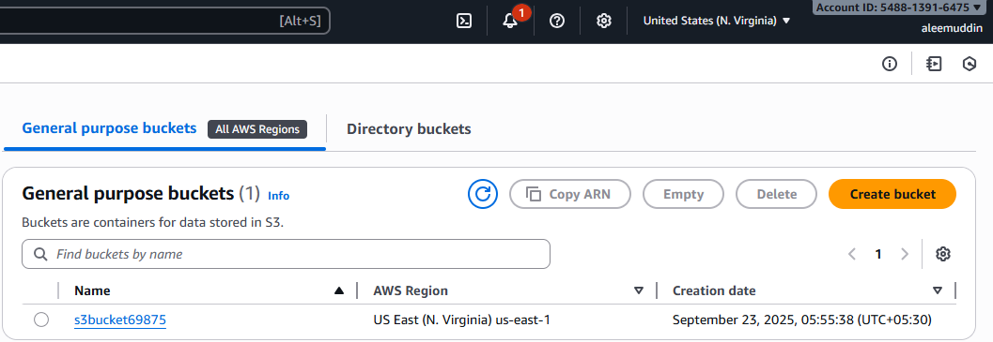
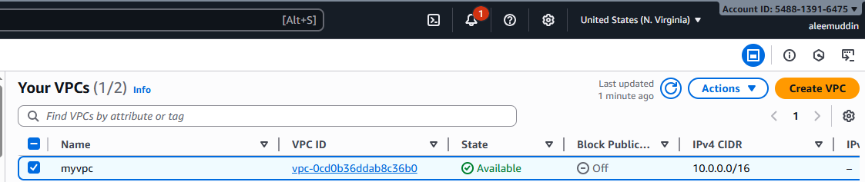
- Provision EC2 for 3 different environments (Dev, Staging, and Prod) using Terraform workspaces.
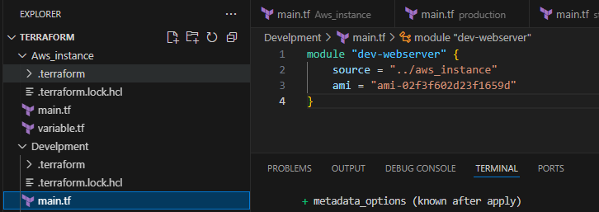
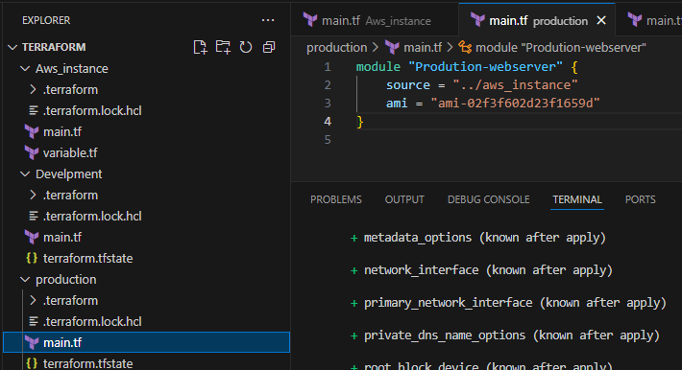
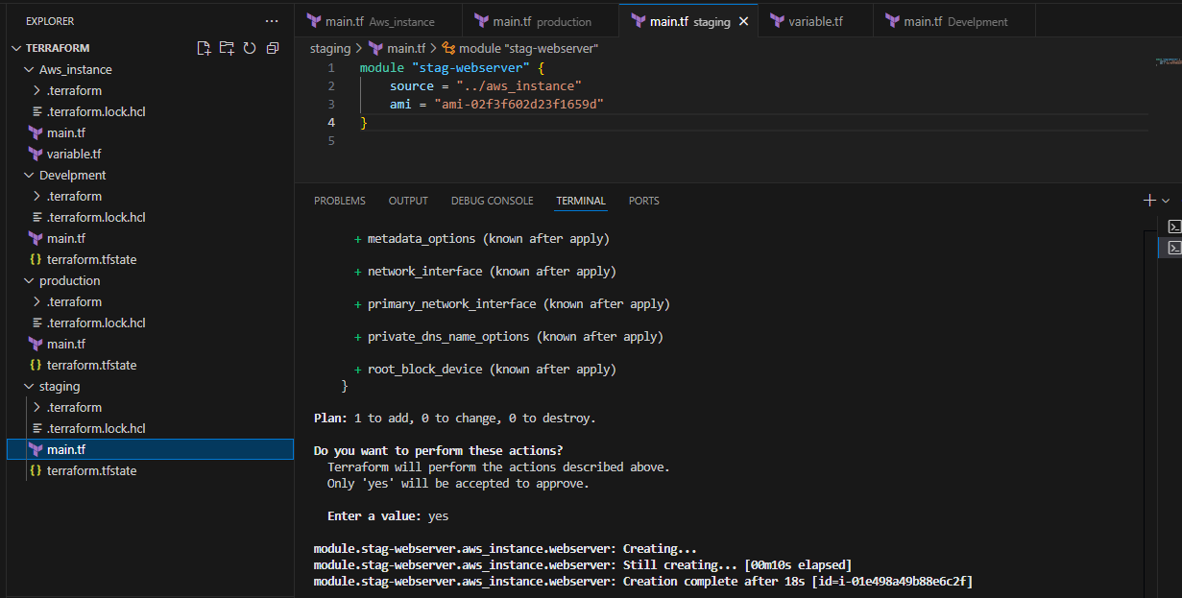
For each directory apply commands:
Terraform init
Terraform apply
We can check instances launched
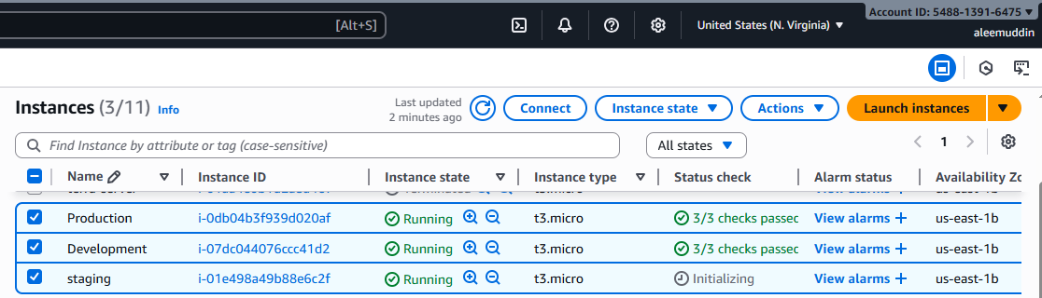
Terraform workspaces:
Workspace can be used if we have multiple project/environments using the same configuration.
terraform workspace new projectA --> to create a workspace names projectA
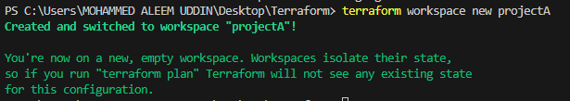
If you want to check which project you are in
Terraform workspace list
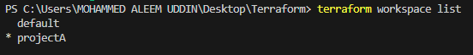
terraform workspace select projectA --> to swtich to specific workspace
